**Development Phase Part -2**

In this phase we add more intents and entities to make the response of the Chabot as much as better.

**Continue Building and Refining responses:**

**Continue Building:**

We make our chatbot to response only for the facebook and facebook messenger queries.

Now ,we will also make the chatbot to respond in the slack application user queries also.

**Intents and Entities**

The several entities created for the slack application queries are as follows:-

1. Greeting message
2. Account creation
3. Payement options
4. Premium features
5. Creating a channel
6. Joining a channel
7. Share a file
8. Workflow builder
9. Record video and audio
10. Privacy settings

**Some of the chatbot responses**

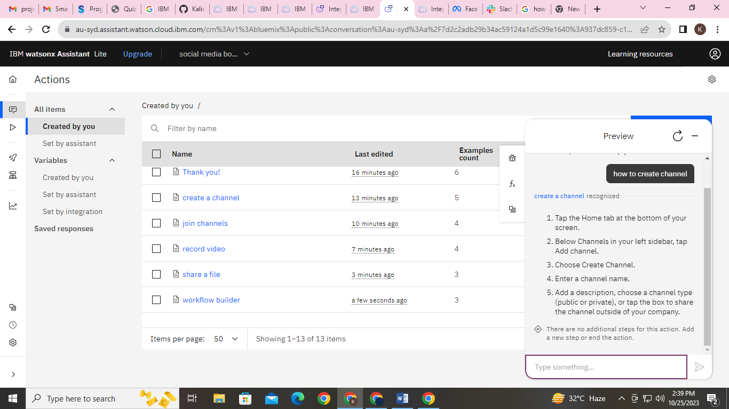 **Creating a channel**

**How to open workflow builder**

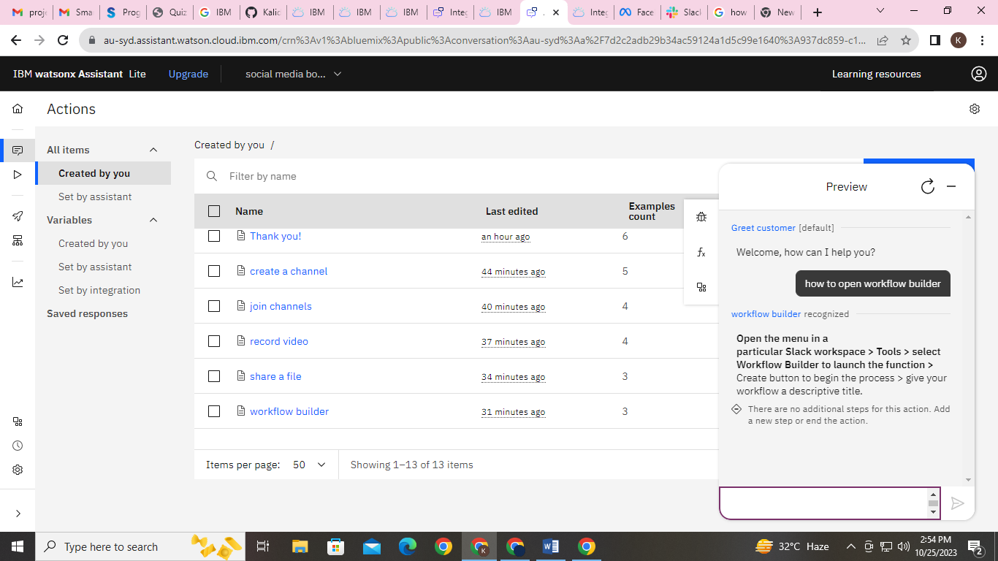

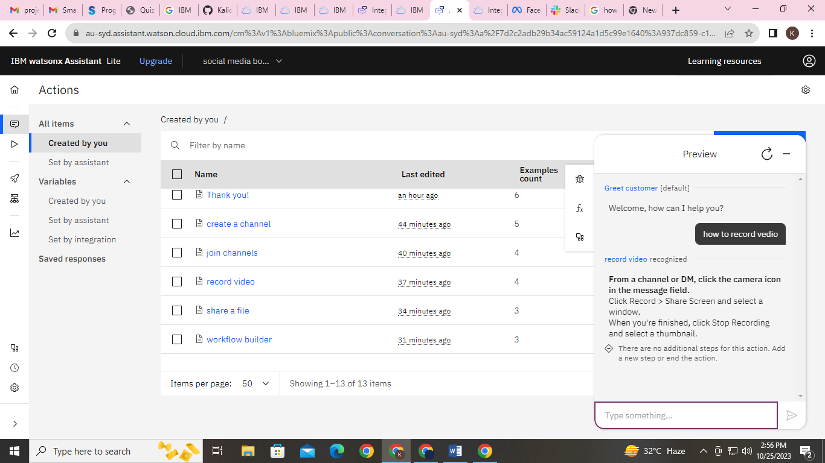**How to record video while sharing**

**Refining Responses:-**

Using the keyword recognition and more than 1 or 2 phrases for an single action to make the response as accurate to solve the query.

Example:-

Action:- Recording

Phrases: - 1.How to record a video?

2. How to record while in a call?

3. How to save my screen play?

4. How to enable recording?

5. Where is the Recording option?

**PLATFORM INTEGRATION:-**

We will integrate the chatbot with Facebook Messenger and Slack using respective APIs.

**Integration with FACEBOOK and SLACK :-**

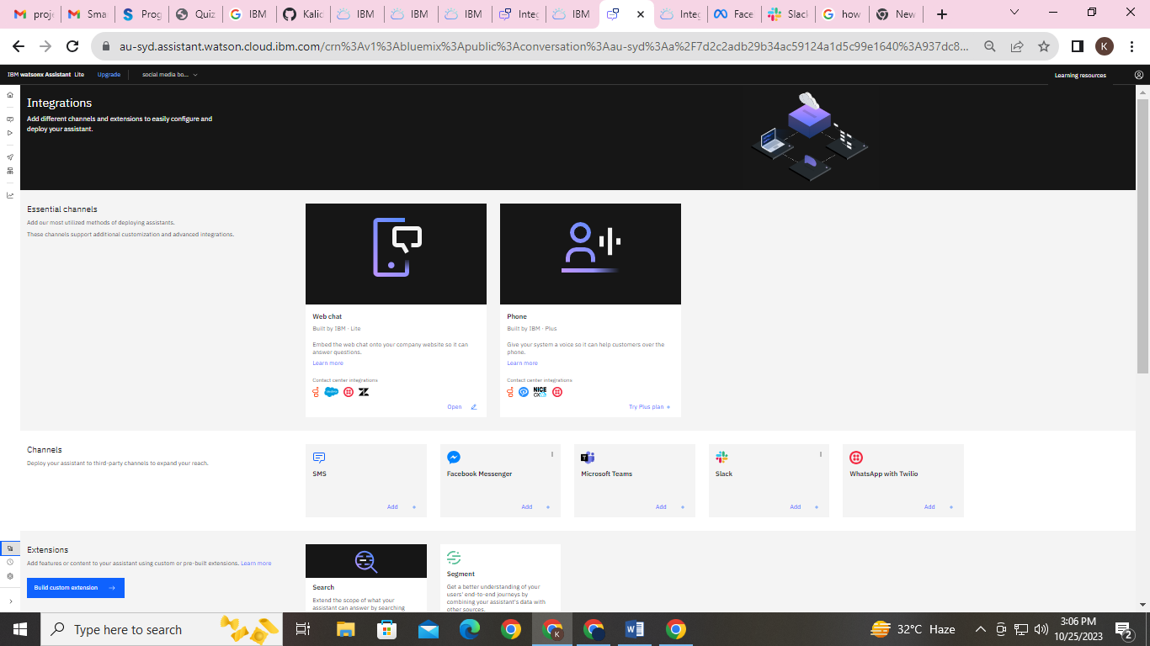

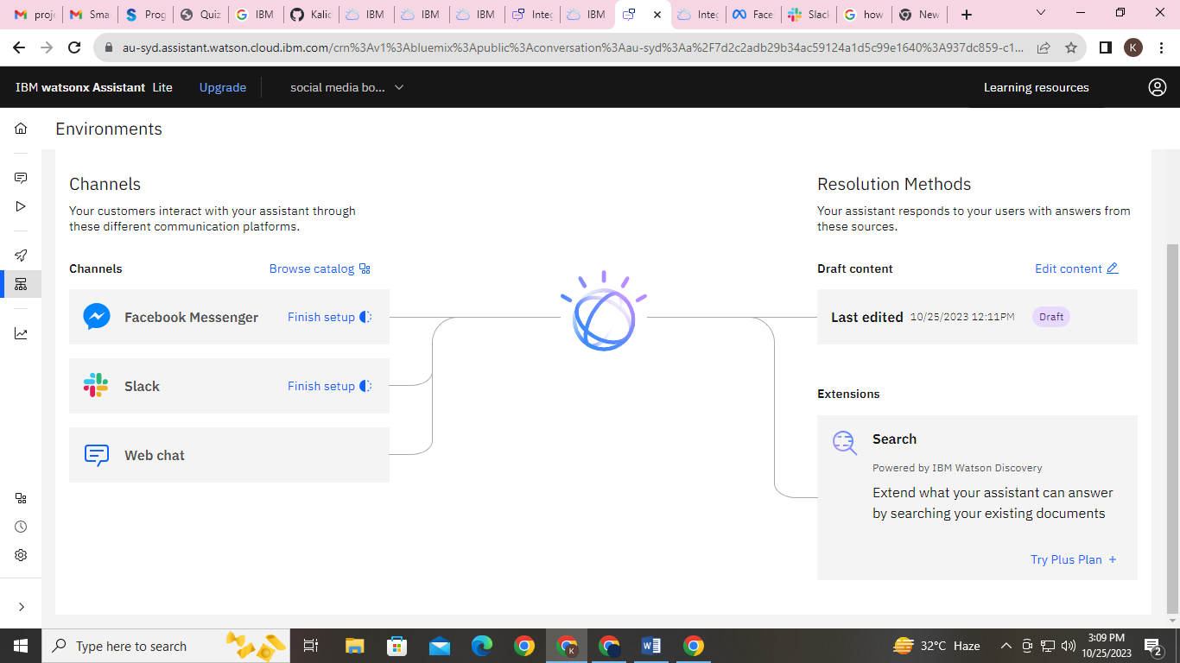

**Integration Chatbot in Facebook**

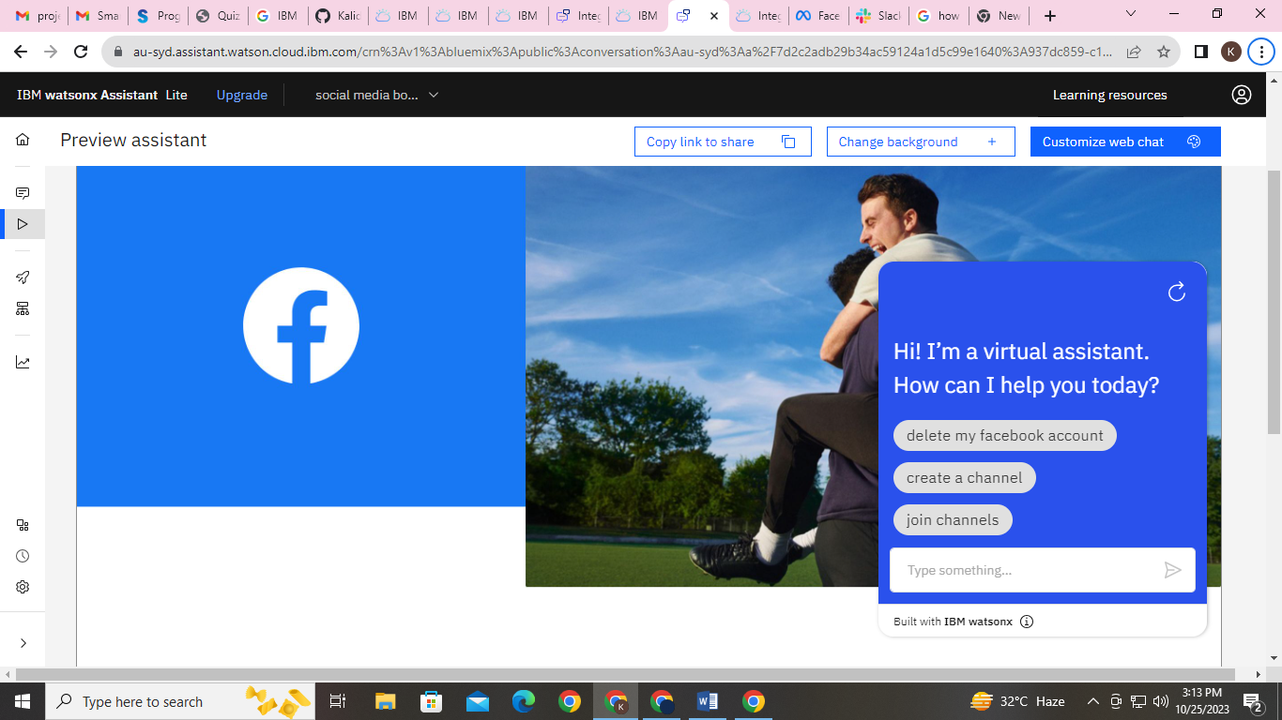

**Integration Chatbot in Slack:-**

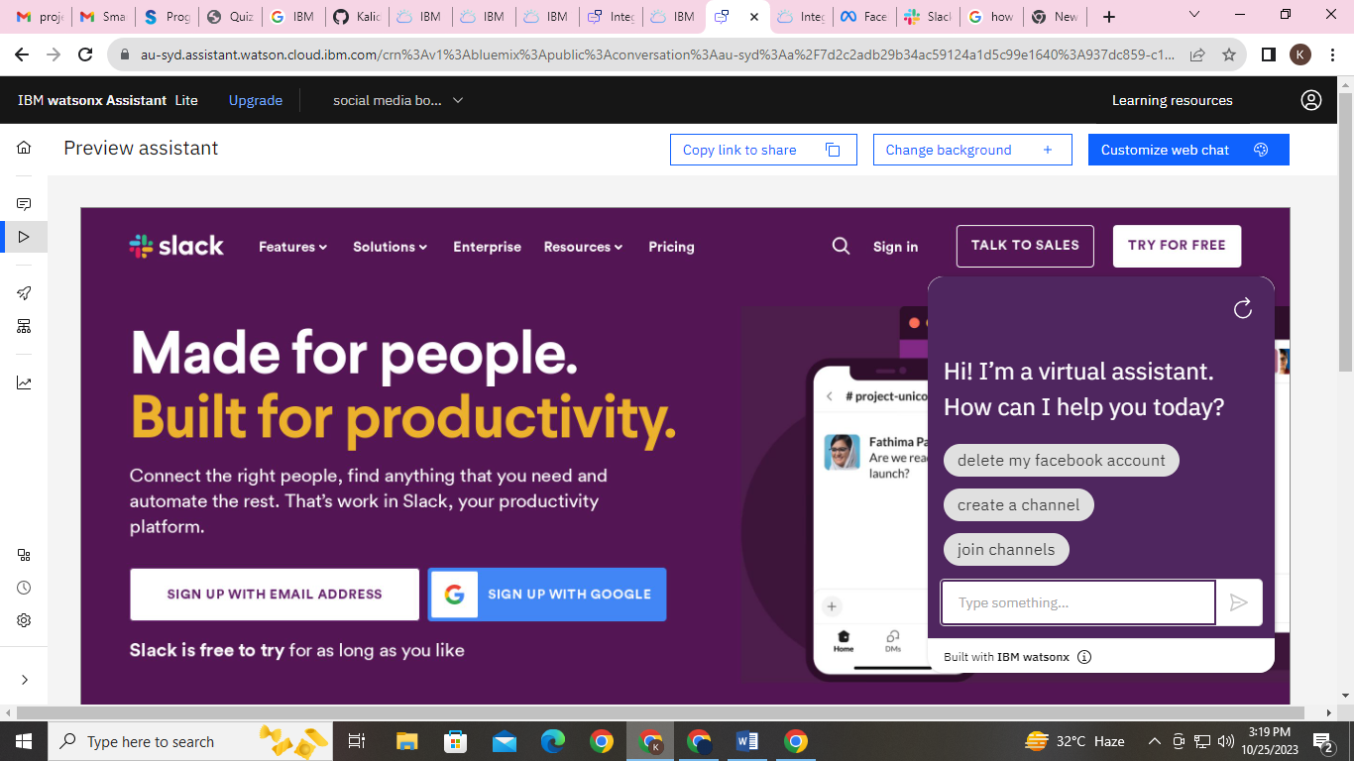

**User Experience:-**

We must make ensure that the conversation flows naturally and that the Chabot’s responses are informative and accurate.

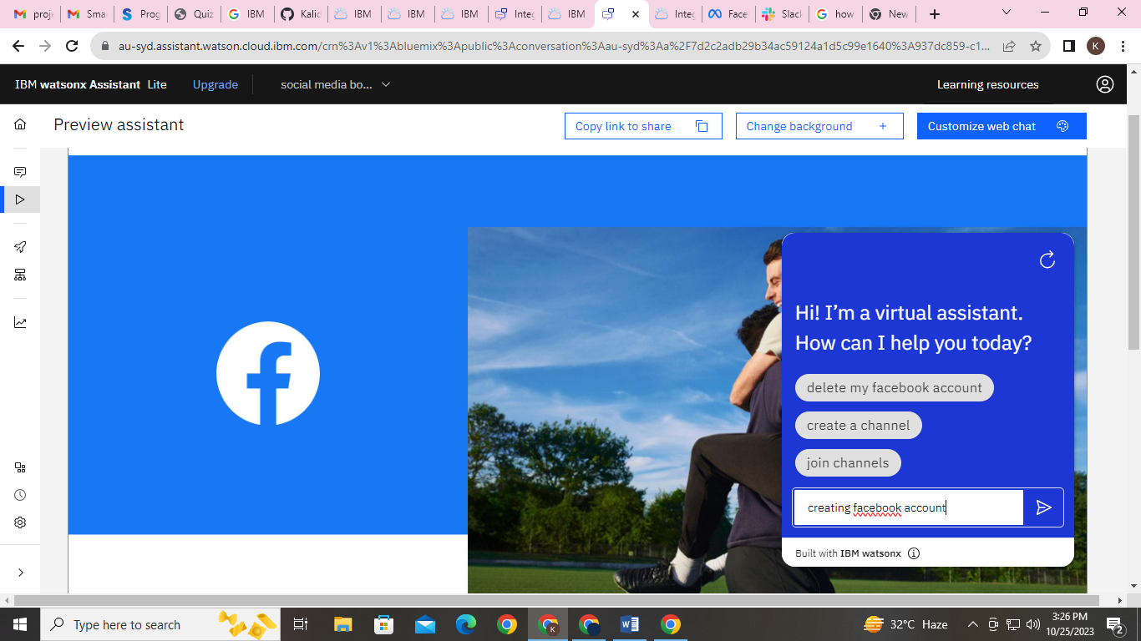 Let we check with one action as follows:-

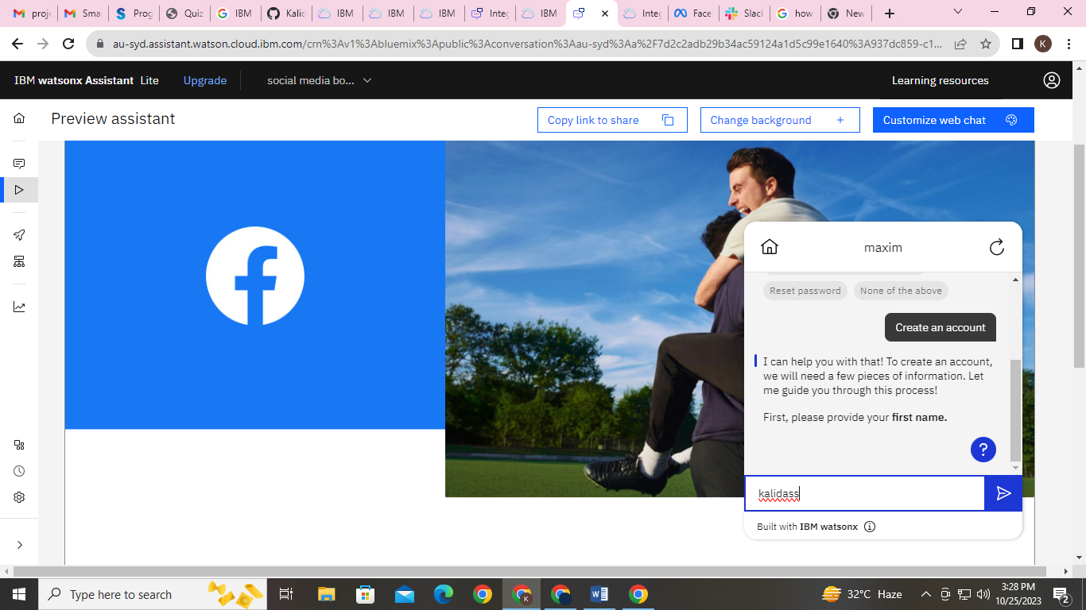

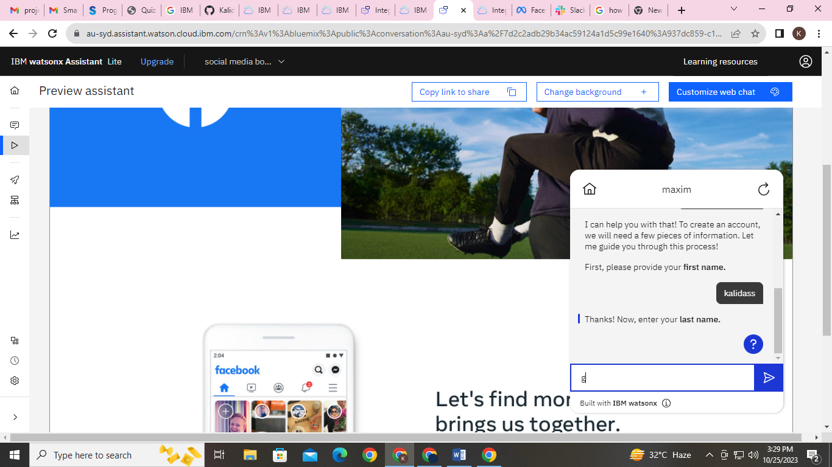

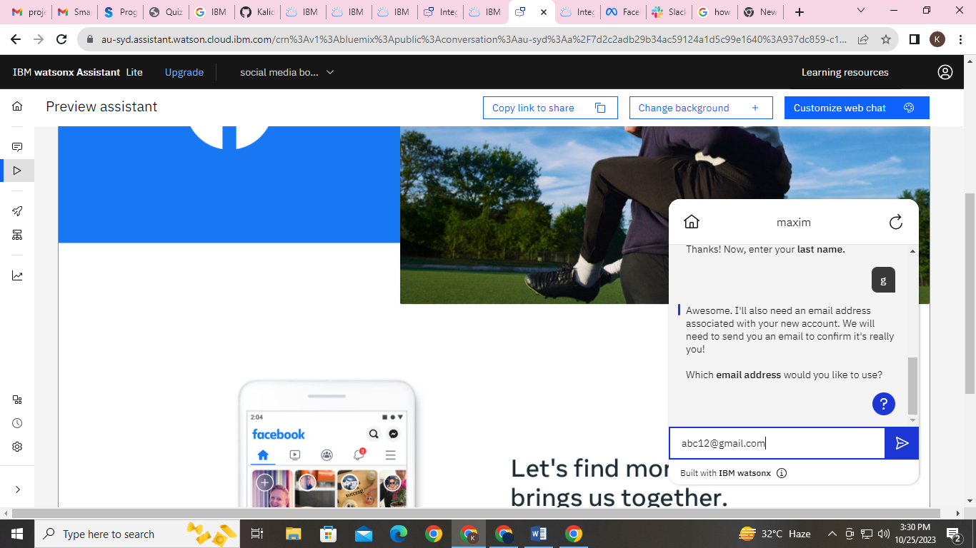

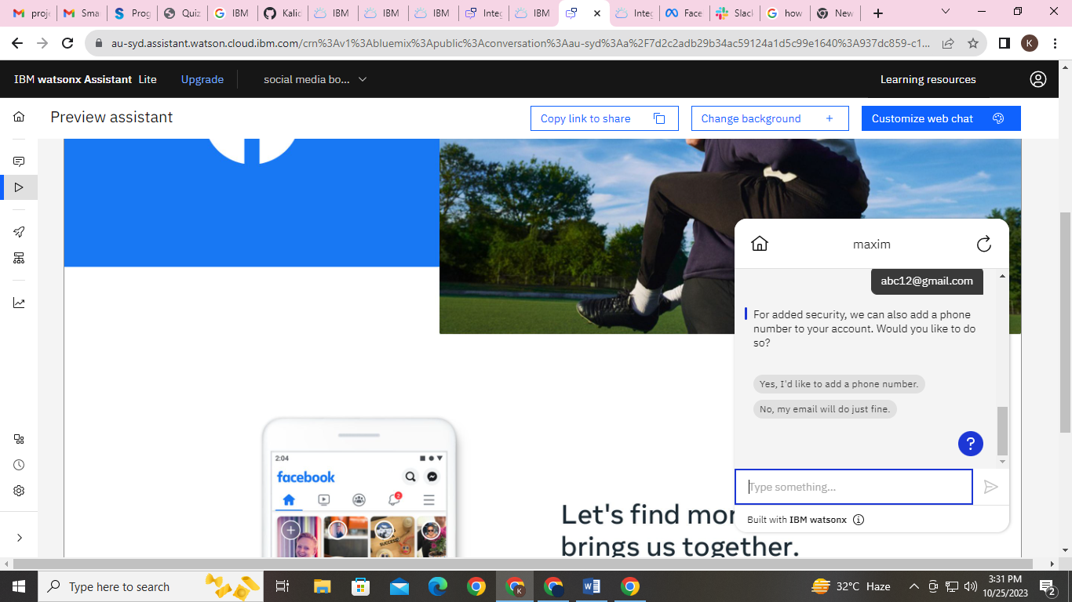

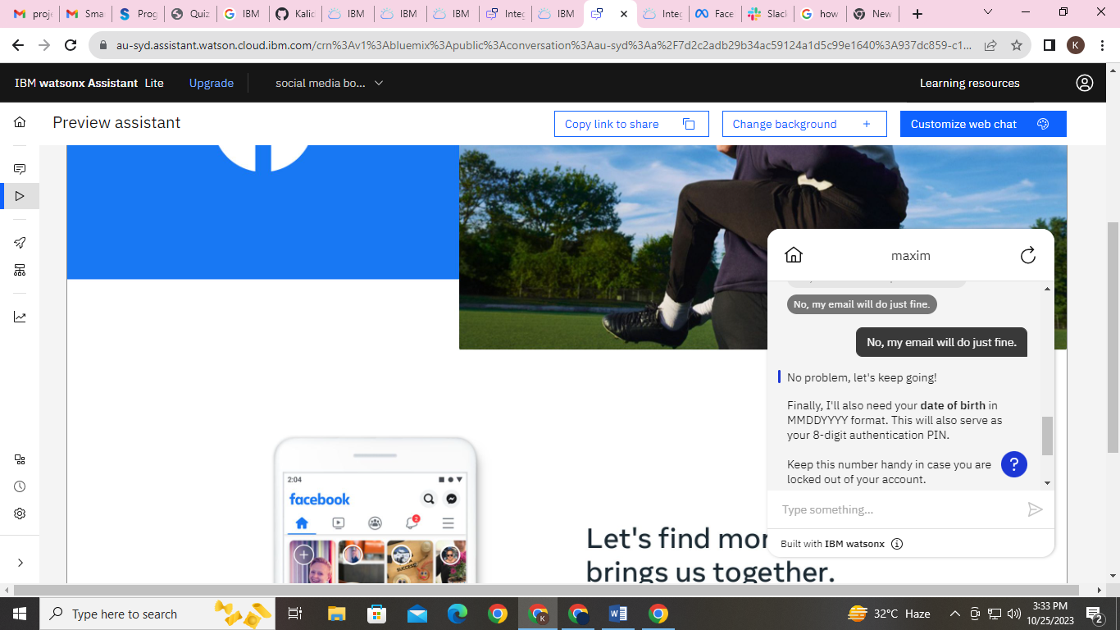

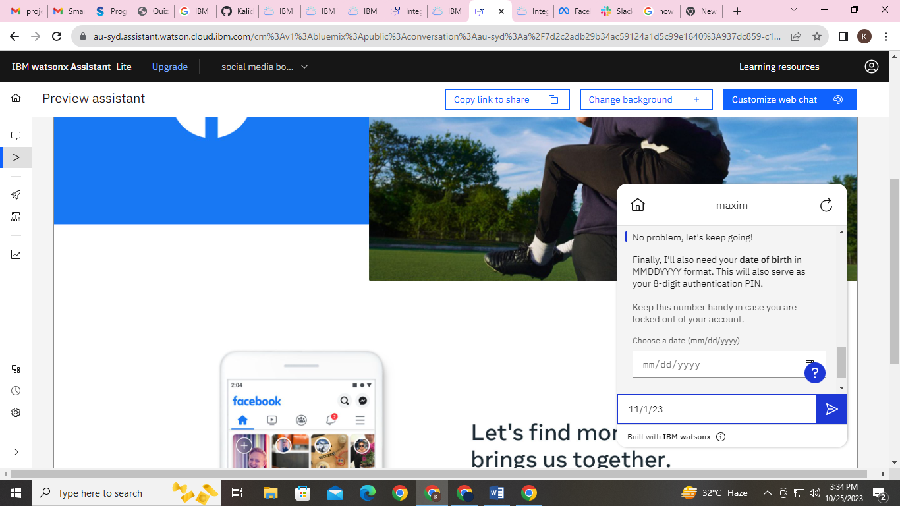

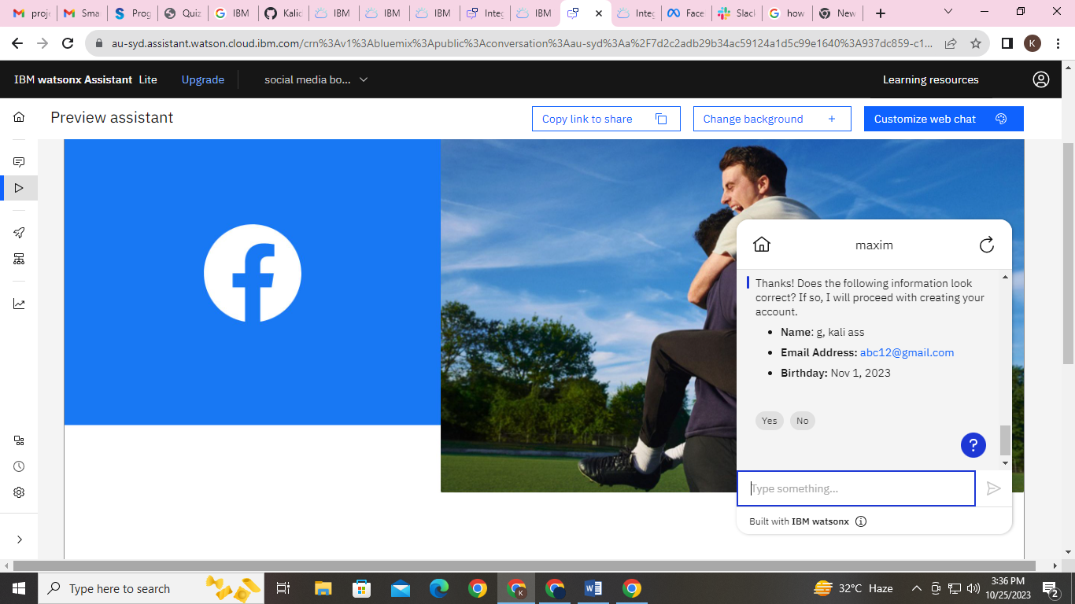

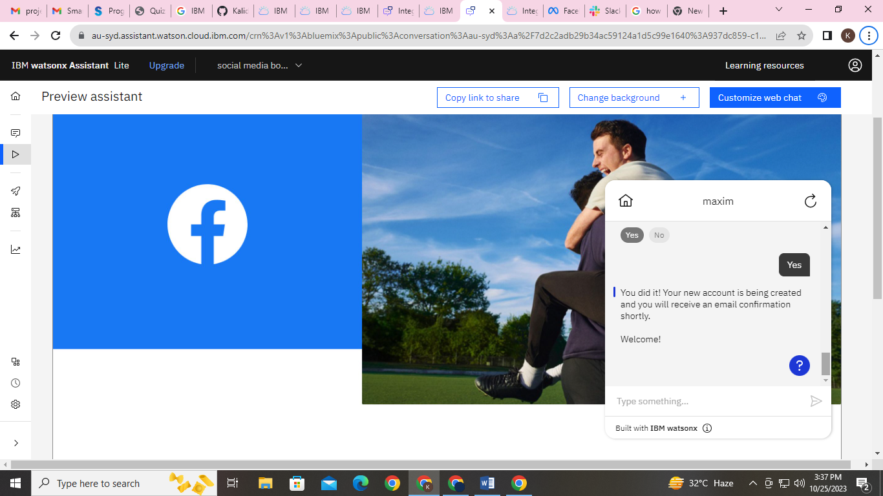

In the above response of the Chatbot for creating an account is user friendly and the conversation flow is very naturally.

It will be more informative to the first users as well as existing users.